**JACO 2 and Syntouch BIOTAC for Evaluating Physical Status of a Patient**

BME 6489 - Socially Assistive Robots

Professor Chung Hyuk Park

Group: Nicholas Steudel, Manish Kumar Sharma, & [Sagar Sharma](mailto:ssharm631@gmail.com)

**Project Introduction**

From assistive surgical robots like the DaVinci Robot to therapeutic robots such as PARO, there are many examples of robotics in medicine. Medical robots have many potential use cases. In general, however, the role of a medical robot should be to help patients and to reduce the workload of hospital staff. While the medical robots in use today have accomplished this to some degree, the applications of these robotic systems are still fairly limited, and adoption is not universal. In order for robotics to further benefit the world of medicine, new robotic systems must continue to be developed.

One primary use case of robotics in a medical environment is in robotic patient monitoring and robotic patient rounding systems. The purpose of this project was to implement new technologies and to begin developing components of a system capable of completing these tasks. More specifically, the purpose of this project was to design a subsystem capable of detecting patient status through the use of computer vision, robotic arm manipulation, and tactile sensing. The primary goal of this project can be broken down into three subgoals: detecting the patient’s wrist with computer vision, moving the robotic arm and end effector to the location of the patient’s wrist through robotic manipulation, and detecting contact, heart rate, and presence of sweat through tactile sensing.

**Vision**

***Abstract***

Vision is the fundamental aspect of completing interactive tasks with a robot. Vision allows for endless opportunities for machine learning and detecting location of objects, allowing for a feedback-driven interaction with robots. In this project, after failing to troubleshoot beyond problems with matlab machine-learning-based wrist detection, a pre-trained depthAI camera is used to assist in identifying the wrist of humans and returning the live coordinates in meters. These coordinates can then be fed to the robotic arm system to help train the arm and move the Syntouch Biotac Sensor towards the wrist. While the vision aspect of the project was achieved, more time could have been spent to find an algorithm to accurately transform the coordinates to a location that could accurately be used by the robotic arm.

***Introduction***

Oak-D Lite depthAI cameras (see fig. 1) by Luxonis allow for robotic vision akin to how a human would perceive the world. These cameras have depth perception and can easily be integrated with existing code for use on a wide range of projects involving computer/robotic vision. Additionally, it also comes with some pre-built demo scripts that can be used as a foundation for projects. In this case, depthAI was the second attempt to identify human wrists and the coordinates of the wrists, and ultimately was what proved to be more prudent than matlab.

***Materials and Methods***

I first spent hours using matlab to write code to import videos, identify the wrist, and output coordinates of the wrist. I was able to train a wrist detector using machine learning utilizing the image labeler app with 4 sample videos from different individuals of the wrist to manually identify the wrist using Matlab and implement it into the code. I wrote a script to call the function and run through each frame of a video and identify the wrist and display the confidence that the object detected is in fact a wrist. The detector was accurate and I was able to submit this for assignment 2 (see Figure 2 for example and uploaded videos for further information).

However, when I tried to output the wrist coordinates, I ran into the problem that the video is 2D and we need 3D coordinates. I considered using a fixed plane so I could grab the X and Y coordinates with a known Z coordinate, but after 4 hours trying to get the coordinates from each frame of the video using a centroid function of the wrist object, I was unsuccessful. I also tried inputting live webcam footage into matlab, but this had the same problem where I could not get the coordinates of the wrist without matlab spewing out errors. Despite collaboration with group members and other classmates at this point, using matlab to get the coordinates seemed to be a dead end without combined expertise. The coordinates are essential to the project as the arm does not know where to move without them.

After much tribulation, I shifted gears away from matlab and to using python with the Oak-D lite camera. However, I ran into many troubleshooting problems here. I originally spent hours using a computer in the lab to run depthAI software in python but was unable to capture the detection of the wrist, the computers seemed to lack the required software. I then tried using the Ubuntu laptop from project 1, but I needed to delete ROS from it, update to Ubuntu 18.04, bootleg download PIP, and then download python 3.7 and set it as priority to run over the pre-installed python 2.7 from Ubuntu 16.04. At this point, I was able to run the depthAI python software in linux seamlessly from the Luxonis website - just need the above ubuntu, PIP, and python 3.7 to run the code. I then implemented code including a pre-trained hand detection model, calling the code with the command *./demo.py -xyz* to isolate the hand object and return the coordinates of the wrist (up to two wrists in one frame). At this point, I could assist with the robotic arm machine learning in preparation for the live demonstration. The coordinates of the wrist are passed on to Manish who can move the arm towards the location of the wrist, and then Sagar can use the sensor to run analyses on the wrist such as whether it is sweaty (wet) or the pulse at the wrist.

***Results and Discussion***

As previously mentioned, the wrist object was correctly detected by both methods. Using matlab, the wrist was able to be detected (see fig. 2 above), but I was unable to extract the live coordinates of the wrist. However, using the Oak-D Lite camera with depthAI, I was able to capture live video, extremely accurately identify wrist objects, and focus in on the wrist and return live-coordinates of the wrist on an interactive screen interface (see fig. 3 below). This worked even better than I had anticipated, and did everything I had the goal of it doing. The only downside was that the coordinates returned were not exactly the same as the coordinates used by the robotic arm. Due to a lack of alignment of times that we could all meet in person to train the robotic arm, we did not perfect the transformation of coordinates from the camera code to coordinates to be used by the robotic arm. In the future, this could be solved experimentally fairly easily using an algorithm to automatically transmit the correct coordinates to more accurately move the arm towards the real-life location of the wrist.

***What was learned?***

This course was my first of the biomedical engineering graduate courses at GWU, so I was a little bit nervous about the learning curve for coding since I only had about one semester prior coding experience, and that was in Javascripts. However, everyone in the class was super collaborative and my classmates and the professor were super friendly, which helped ease the steep learning curve. I am now excited to continue learning about other aspects of biomedical engineering through the rest of my course at GWU.

As a result of not knowing much about robots, coding, or biomedical engineering, I learned so much throughout the course. I particularly enjoyed the lectures learning about the applications of robots in medicine, and in general. The opportunities to explore utilizing robots are truly endless. Along that same token, I also learned to appreciate how arduous the process is to not only code, but particularly to fine tune robot code. It is a LOT of work, but worth it in the end. I also found the articles we read about the ethics and culpability of robotic accidents very interesting, as that is an aspect of robotics that I have not thought about but is very relevant in the modern world.

In addition to the lectures, I also enjoyed listening to the individual ~weekly presentations on various developments and applications of robotics in biomedical engineering. By the end of the course, I became very comfortable with Linux, Matlab, Python, and vision processing, all of which I had absolutely no experience prior to the course. I appreciate that the assignments were so interesting that I did not even think about how much I was having to troubleshoot with the end goal in mind, so much so that the learning of the intricacies of the various languages came naturally. In particular, I liked that this final project was very much like a real-world situation where you are given a problem and required to develop your own solution based on what you know and sometimes similar examples you can find online and utilize to model solutions. Overall, I really enjoyed the course and learned so much that I never imagined learning while working a full time job upstairs from the classroom.

**Robotic arm**

***Abstract***

In the medical industry, notably in surgery, robotic arms are becoming more common. These robotic devices can provide a variety of advantages, such as enhanced precision and accuracy during surgeries, improved ergonomics for surgeons, and the possibility to do procedures remotely.

The da Vinci surgical system, for example, comprises a console where the surgeon sits and controls the robotic arms, as well as a patient-side cart with four robotic arms that are used to perform the surgery. The arms are controlled by the surgeon through hand and foot pedals, and they are outfitted with a variety of surgical equipment as well as a high-definition camera that allows the surgeon to look inside the patient's body during the treatment. Robotic arms are also utilized in rehabilitation and physical therapy to assist patients in doing exercises and movements that would be difficult or impossible for them to perform on their own. Furthermore, robotic arms are being researched for use in telemedicine, where they can be utilized to perform some medical procedures remotely or assist with diagnosis.

The ROS operating system is utilized to control the JACO 2 arm. In close collaboration with ROS, Ubuntu is utilized to run ROS. The algorithm was written in Python, a general-purpose, high-level programming language. MATLAB generates a trajectory after the waypoint is created. Jaco 2's arm follows the trajectory. The model is given the coordinate, and it trains to detect the object.

***Introduction***

The Kinova Gen 2 robotic arm is a lightweight and compact robotic arm that may be used in a range of applications such as manufacturing, research, and healthcare. It has six degrees of freedom, allowing it to move in multiple directions and accomplish tasks that require precision movement and positioning.The high payload capacity of the Kinova Gen 2 robotic arm, which allows it to carry a wide range of tools and payloads, is one of its primary strengths. It also has a variety of sensors and control algorithms to conduct tasks with great accuracy and reproducibility.

The Kinova Gen 2 robotic arm is frequently used in the healthcare profession as an assistive device for people with disabilities or injuries, assisting them in performing tasks that would be difficult or impossible for them to do on their own. It can also be utilized in rehabilitation and physical therapy to assist patients in performing exercises and motions that may be difficult for them. Overall, the Kinova Gen 2 robotic arm is a versatile and dependable instrument that can be utilized to improve efficiency and accuracy in a range of applications. It exemplifies the role that robotics can play in improving healthcare and other industries.

Some of the elements employed to achieve the objective are:

Robot: Kinova JACO 2 arm

Operating system: Ubuntu, ROS, and MATLAB & Simulink

Programming languages: Python 2.7 and Python 3.8

***Materials and Methods***

The trajectory was created using Matlab. A waypoint is created before the trajectory, which is then followed by the arm. For trajectory construction, I used the Matlab trajectory demo. We construct a waypoint function file that will subsequently be imported and published. There is also a function for importing the robotic arm. The ROS node is linked to the trajectory algorithm through a Simulink file. Simulink is a dynamic system modeling and simulation tool that includes a graphical editor, customizable block libraries, and solvers. Then we create an algorithm to assist us in designing the trajectory and controlling the velocity and torque values.We employed the Inverse Kinematics and Trapezoidal functions. In the trapezoidal shape the arm advances from one waypoint to another, the velocity is initially great, but as soon as we reach the next point, it decreases, then raises, and then repeats the process.

Used the demo file in the second step. We modified the algorithm to meet our needs.We altered the velocities several times and tested them with the robot. The most appropriate velocity of 0.75 was then determined to be ideal for our purpose. When vision control recognizes the wrist coordinates. Sin X, Sin Y, and Sin Z; Cos X, Cos Y, and Cos Z are the six coordinates. We manually enter the coordinates into the command prompt. The arm advances toward the wrist in the shortest possible path, detecting the pulse and the essential data. After collecting the data, it is transferred for filtering.

***Results and Discussion***

A robotic arm that is able to follow a set of coordinates and grip an object using its fingers, based on visual input from a sensor. As a result, we enter two sets of coordinates: one for pose control and one for finger control. The sensor finger is opened by the finger control, while the other remains closed. It's also worth considering the use of an algorithm to optimize the movement of the arm. For example, the algorithm could determine the shortest path from the current position of the arm to the target coordinates, which would allow the arm to move more efficiently and potentially reduce the time required for the task.

If we had more time, we could have created an algorithm. Which detects the coordinates from the wrist control automatically. It then feeds the robot arm, which takes the shortest path from wrist detection. Depending on the specific requirements of the application, there are various approaches that could be taken to design and implement such an algorithm. Some potential considerations could include the type of sensor being used for visual input, the desired accuracy and speed of the arm's movements, and the complexity of the task being performed.

***What was learned?***

This was the most valuable class I took this semester. When the goal was first proposed, it appeared difficult. However, as the classes progressed, everything appeared to become simpler. I learned how to use the Linux command line and the fundamentals of the Robotic operating system. There are several key aspects of controlling a robotic arm, including:

* Kinematics: This involves understanding the movements and positions of the arm's joints and how they relate to one another.
* Dynamics: This involves understanding the forces acting on the arm and how they affect its movements.
* Sensors: Robotic arms often have a range of sensors, such as encoders and accelerometers, that provide information about the arm's position and movements.
* Control algorithms: These are used to process the information from the sensors and determine the appropriate actions for the arm to take.
* Programming: Programming languages such as C++ and Python are often used to write code that controls the movements and actions of the robotic arm.

Overall, controlling a robotic arm involves a combination of understanding the physics of the system, using sensors to gather information, and using control algorithms and programming to execute the desired actions. Learned how to use MATLAB to create the trajectory. The machine learning toolbox was used to control the robot's arm movements. Also learned how robots may be valuable in the medical industry. From doing surgery to supporting individuals and making work less stressful. There is still more work to be done, but with the help of computer vision and reinforcement learning, many problems can be solved in the future. In the future, I hope to learn more about Reinforcement Learning and directing robots.

**Tactile Sensing**

***Abstract***

The primary goal of using a tactile sensor in this project was to determine a patient's status based on readings from the sensor. In order to do so, the team employed a Syntouch Biotac Tactile Sensor. DC pressure readings from the sensor were meant to be used to classify, while ac pressure readings (micro vibrations) from the sensor were meant to be used to classify heart rate as well as presence of sweat. While not all of the goals were accomplished, sensor readings were successfully used to classify when contact was made with a patient as well as whether or not the patient was sweating.

***Introduction***

Tactile sensing in this project was accomplished through use of a Syntouch Biotac Tactile Sensor. The Syntouch Biotac Tactile Sensor is a robust tactile sensor which attempts to be biomimetic through the use of an elastic material for the outer structure and a fluid filled core.The structure can be visualized in **Figure 6**. This sensor is able to detect AC pressure, DC pressure, AC temperature, DC temperature, and impedance. Through these readings, the sensor is able to quantify the ‘sensation’ of human touch.

In this project, the sensor can be thought to be mimicking a doctor or nurse touching a patient's wrist. Through this touch, it was hoped that the tactile sensor would be able to detect contact with a patient, a patient's radial pulse, and sweat on the patient's skin. It was expected that contact would be correlated with an increase in DC pressure, radial pulse would be correlated with some unknown frequency trend in AC pressure, and that there would be a difference in the frequency spectrum of AC pressure between wet skin and dry skin.

***Materials and Methods***

As previously mentioned, tactile sensing in this project was accomplished through the use of the Syntouch Biotac Tactile Sensor. All data processing and programming was performed using Python 3.10. Data collection was accomplished by using the sensor along with the provided GUI. For radial pulse, 30 initial samples of varying time lengths were collected. 10 samples represented 100 beats per minute, 10 samples represented 90 beats per minute, and 10 samples represented 45 beats per minute. This data was also used for contact/no contact. For wet and dry skin (presence of sweat), 10 samples of varying time lengths were collected for each respective classification.

After collecting data, the data had to be preprocessed. The data provided by the sensor's GUI is given in a .btd format. In order to properly handle the data in Python, it had to be converted to a more acceptable format. In this case, .xlsx was used. In order to perform the conversion, a simple function was written. This function, which can be seen in **Figure 7**, simply converts a given .btd file to a .txt file, which is then converted to a .xlsx file. Another custom function is called in this function, ttx.txt_2_excel(). This can be seen in **Figure 8**. It is simply used to convert the text file. From here the data was ready for processing in Python. The data was loaded into Python by using the Pandas library. The Pandas library provides a built-in function which loads excel data into a Pandas dataframe (However, as can be seen in **Figure 9**, the data provided by the sensor is extremely messy and maintains this format even when loaded into Python. Therefore, after utilizing the pandas library to load in the data from the excel file into a pandas dataframe, the data had to be cleaned up. This was accomplished by taking into account the nature of how the data was provided and by manipulating the Pandas data frame to only provide the relevant information. The function, which accepts an excel file path as an input and provides the cleaned data as an output (still stored in a Pandas dataframe), can be seen in **Figure 10**. The data before being cleaned can be visualized in **Figure 11** and after being cleaned can be visualized in **Figure 12**. With the data finally loaded into Python and cleaned up, the next step was to extract the necessary values. In this case, AC pressure and DC pressure were the primary values being analyzed, however AC temperature and DC temperature were also extracted. Extraction of appropriate values in a single function was accomplished by taking into account the sample rate of AC pressure within a given frame of collected data (each frame of collected data held 44 data points, not to be confused with the Pandas dataframe which holds all of the frames of collected data). For any given frame in a dataset, every other value collected represented an AC pressure value. Therefore, every other value in the ‘bits’ column of the Pandas data frame was stored in a numpy AC pressure array which held the corresponding time values as well. DC pressure and the two temperature values, on the other hand, are stored at the end of a given frame of collected data. These were extracted by determining when the index was at the end of a frame of the sampled data, and using the position of the desired values relative to this point. This function returned 5 NumPy arrays. One corresponding to each desired signal value and one to represent the total time that data was sampled for. The function can be seen in **Figure 13.**

This extracted data was then utilized to attempt to find trends which correlated to the physical occurrences taking place. The data was plotted in the spatial (time) domain as well as the Frequency Domain by taking the discrete fourier transform. The fast fourier transform algorithm utilized to compute the DFT of the desired signal was provided by the NumPy library. These plots were used to find trends in the signals as discussed in the hypothesis (spike in DC pressure for contact, frequency domain trend of AC pressure for heart rate, frequency domain trend of AC pressure for sweat).

After finding trends amongst features for the desired physical statues, the next step in the procedure was to extract the desired features from the signals and to build classifiers. For detecting contact, the feature determined to best classify between contact and no contact was the average of the DC pressure across a one second period of time. This means that the feature would be an average of approximately 100 DC pressure data points (there is one DC pressure sample every .01 seconds). The goal of the classifier would be to determine whether contact has been made or not based on the average DC pressure over one second of data. In order to properly extract the correct data from each sampled set of data, the first step was to write a function to extract a certain time frame of data from the DC pressure data. This function, which can be seen in **Figure 14**, accepts a numpy array of data DC pressure data along with a start time and end time (given in whole seconds as input). The function returns the desired time frame of data as a NumPy array. From a given time frame of data, the next step was to extract the one second averages. So, for example, if six seconds of contact data were extracted using the function in **Figure 14,** this data would be able to provide six data points for the classifier (six one second averages. To extract the one second averages, a separate function was built. This function, which can be seen in **Figure 15**, accepts a numpy array of resampled DC pressures as an input, and outputs a list of the averages across each one second interval. Therefore, if six seconds of DC pressure data is input into the function, a six element list will be returned. These two functions were used in conjunction with each other to extract features from various trials, store the features in a list, and assign labels based on the data being analyzed.. The labels were either “Contact” or “No Contact”, and the feature vector consisted of the average DC pressure for the given one second of data. This labeled dataset was used to train a K-Nearest-Neighbors classifier to differentiate between when contact is being made and when no contact is being made. For this model, the neighborhood size was set to five and the train/test split was set to 85/15. Label encoding was used to encode the labels ( 0 = “Contact”, 1 = “No Contact”). The classifier was trained by utilizing the SciKit Learn library, and saved with the Joblib library. The code for training the contact/no contact classifier can be seen in **Figure 16**.

In the case of differentiating between the presence of sweat and no sweat, the best features were determined to be the the average magnitude of frequencies present at 10,20,30, and 40 Hz for AC pressure data, as well as the average AC pressure value in the time domain for any given one second of data. In order to extract these features (and to eventually label them), custom functions had to be written. The first function written, as seen in **Figure 17,** was written to extract a certain time frame of AC pressure data from a given data set. The function from detecting contact/no contact could not be used here/can not be used here due to the difference in sampling frequency between AC pressure and DC pressure. This function accepts a NumPy AC pressure array and a start and end time (in whole seconds) as input. The output of the function is the resampled data. The function to extract the average magnitude of the frequency over the desired frequency range can be seen in **Figure 18**. This function accepts a NumPy array of AC pressure values as input, calculates the Fourier Transform of the signal, and returns the desired average value. The function used to extract the average AC pressure value over a one second period in the time domain can be seen in **Figure 19.** For the same reason as before, the DC pressure function could not be reused here. This function works similar to the one written for DC pressure and also returns a list of one second averages. These functions were once again used in conjunction with each other to extract features from various trials, store the features in lists, and assign labels depending on the data being analyzed. The labels in this case were either “Sweat” or “No Sweat”, and the feature vector consisted of the average frequency magnitude of the AC pressure data for frequencies from 10-40 Hz as well as the average AC pressure value in the time domain for any given one second of data. This labeled dataset was used to train a Support Vector Machine Classifier to determine whether a patient was sweating or not. For this model, a linear kernel was utilized and the train/test split was set to 85/15. Label encoding was once again used to encode the labels (0 = “Sweat”, 1 = “No Sweat”). Once again, SciKit Learn and Joblib were used to train and save the model respectively. The code for training the sweat/no sweat model can be seen in **Figure 20.**

***Results and Discussion***

As discussed above, trends were successfully found in the data for contact and presence of sweat. **Figure 21** shows a plot of DC pressure data where the first few seconds of data have no contact, while the middle of the dataset represents contact. This trend was the basis for training the K-Nearest-Neighbors Model (contact/no contact model). This model was shown to have 89.7%accuracy in training and 100%precision in training. The model was trained with 254data points, with an equal split between contact and no contact points. The confusion matrix for the model can be viewed in **Figure 22.** The model seems to perform well, and also performed well in a live testing environment (on data it had never been exposed to before).

**Figure 23** shows the magnitude of the frequencies from 10-40 Hz of wet skin on the left and dry skin on the right (AC pressure). Clearly, there are spikes in these frequencies for wet skin. The graph on the left of **Figure 24** shows the AC pressure in the time domain for wet skin and the graph on the right shows it for dry skin (ignoring the first few and last few seconds of data for both for the time when the sensor was not in contact with the skin). There is clearly some spike in AC pressure (micro vibrations) which occurs for wet skin. These two trends in the frequency and time domain were the basis for training the Support Vector Machine Classifier (sweat/no sweat model). This model was shown to have 100%accuracy in training and 100%precision in training. The model was trained with 17data points, with an even split between contact points and no contact points. The confusion matrix for this model can be visualized in **Figure 25**. The model performed well in training, but not as well in live testing (testing against data it had never been exposed to before).

While good trends existed in the data for contact and sweat, unfortunately there was no discernable trend found to detect radial pulse. After undergoing much trial and error with different signal processing techniques, the data collected was simply found to be too noisy to find any trend in heart rate with the signal data. Not only were the signals processed and analyzed in the time domain, but the frequency domain as well. On top of this, even though it was hypothesized to find a trend in AC pressure data, the DC pressure data was also analyzed in both domains. The original AC pressure data, plotted against time, can be seen in **Figure 26.** Clearly, there is too much noise in the original signal to find any trend (even after analyzing in smaller time frames). The same is true for the DC pressure signal, as seen in **Figure 27.** These signals were filtered with many different types of filters, including smoothing with Hann Kernels of different sizes, cosine Kernels, and boxcar kernels. Along with this lowpass filtering with a cutoff frequency of 60 Hz was used. Features and patterns were searched for in the signals after each of these attempts, but nothing which correlated to the correct heart rate could be found. As an example, **Figure 28** shows the AC pressure signal after being filtered with a Hann kernel of size 501 (such a large kernel size was used to accommodate the large number of data points in the AC signal). The same steps were repeated with the DC pressure signal. **Figure 29** shows the DC pressure signal, after being resampled to one sample every quarter second in the time domain with and without the DC component and in the frequency domain with and without the DC component. One sample every quarter second was selected for the resampling rate due to the fact that if there were a beat every quarter second, this would correspond to a heart rate of 240. This is well outside the normal range for heart rate, and therefore if there were some trend in the time data, it would be visible within this rate of resampling. The signals which were collected were noisy due to the method in which they were collected. The sensor was placed in one hand and was placed on the radial artery with the other. Not only is the signal inherently prone to noise as all signals are, it was also subjected to the movements of both arms. Even the slightest tremor or shake in one of the arms proved to produce too much noise.

In order to further this experiment, the first thing I would do is increase the amount of data used to train the contact/no contact and sweat/no sweat models. While both models performed well in training, they only performed moderately well when tested against real data. This can mostly likely be attributed to the small datasets used to train each model. The contact model was trained with 254 data points while the sweat model was trained with 17 data points. Increasing both data sets to approximately 500-750 data points should allow both models to perform extremely well against real data as well. As of now both models show promise, but need to be trained with more data. In terms of detecting heart rate, this project should be repeated but with a more controlled environment. If the tactile sensor is placed against the radial artery by either the JACO arm or some other mechanical mechanism and the arm is held very still somehow, it would be possible to get much cleaner data/reduce the amount of noise. With cleaner data it may be possible to detect a trend between AC pressure and heart rate or DC pressure and heart rate.

***What was learned?***

This course, and specifically this project, taught me a lot about the practical applications of the theoretical aspects of robotics. Most courses tend to teach theory and test on theory; however, in this course we were taught theory during lectures and were actually applying the theory with the assignments and the project. For example, I had learned a lot about the theory of signal processing (especially regarding the Fourier Transform) from my undergraduate signal processing course, however I had never actually processed a signal before or taken its Fourier Transform. However, for this course, this became necessary. I was able to learn how to practically take the Fourier Transform of a discrete time signal and how to process this type of signal. Another example of this is from learning about machine learning. Before taking this course, I had only learned a little bit about machine learning and most of it was theoretical information from books or articles I had read personally. After learning about machine learning in this course, I had to apply it for Assignment 2 as well as for my portion of the final project. This final project was the first time I had ever trained a machine learning model. Before doing so for this project, I had always been extremely confused about how the training process occurred and thought it was some complicated process. I was able to train 2 machine learning models for this course, and analyze the results of those models. I was also able to test those models against real data. This in turn gave me the opportunity to ‘debug’ my models and see where short comings were. I was able to see how I could improve those models and make them more functional in the future. Now the process/theoretical concepts seem much more clear to me. All in all, I have truly enjoyed this course because not only was I able to learn theory in class, but I was able to apply it for the assignments and projects. This application of theories allowed me to learn more about the theories while also learning about how those theories translate to the real world. Along with this, I also learned about how different aspects of a robotics system combine to form a complete robot. It showed the importance of collaboration in projects such as this. Without proper collaboration between team members and robotic components, this type of project would not function properly.

**Appendix**

**Vision Figures (Nick)**

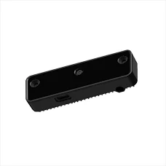

Figure 1: Oak-D Lite camera used for vision and wrist object detection

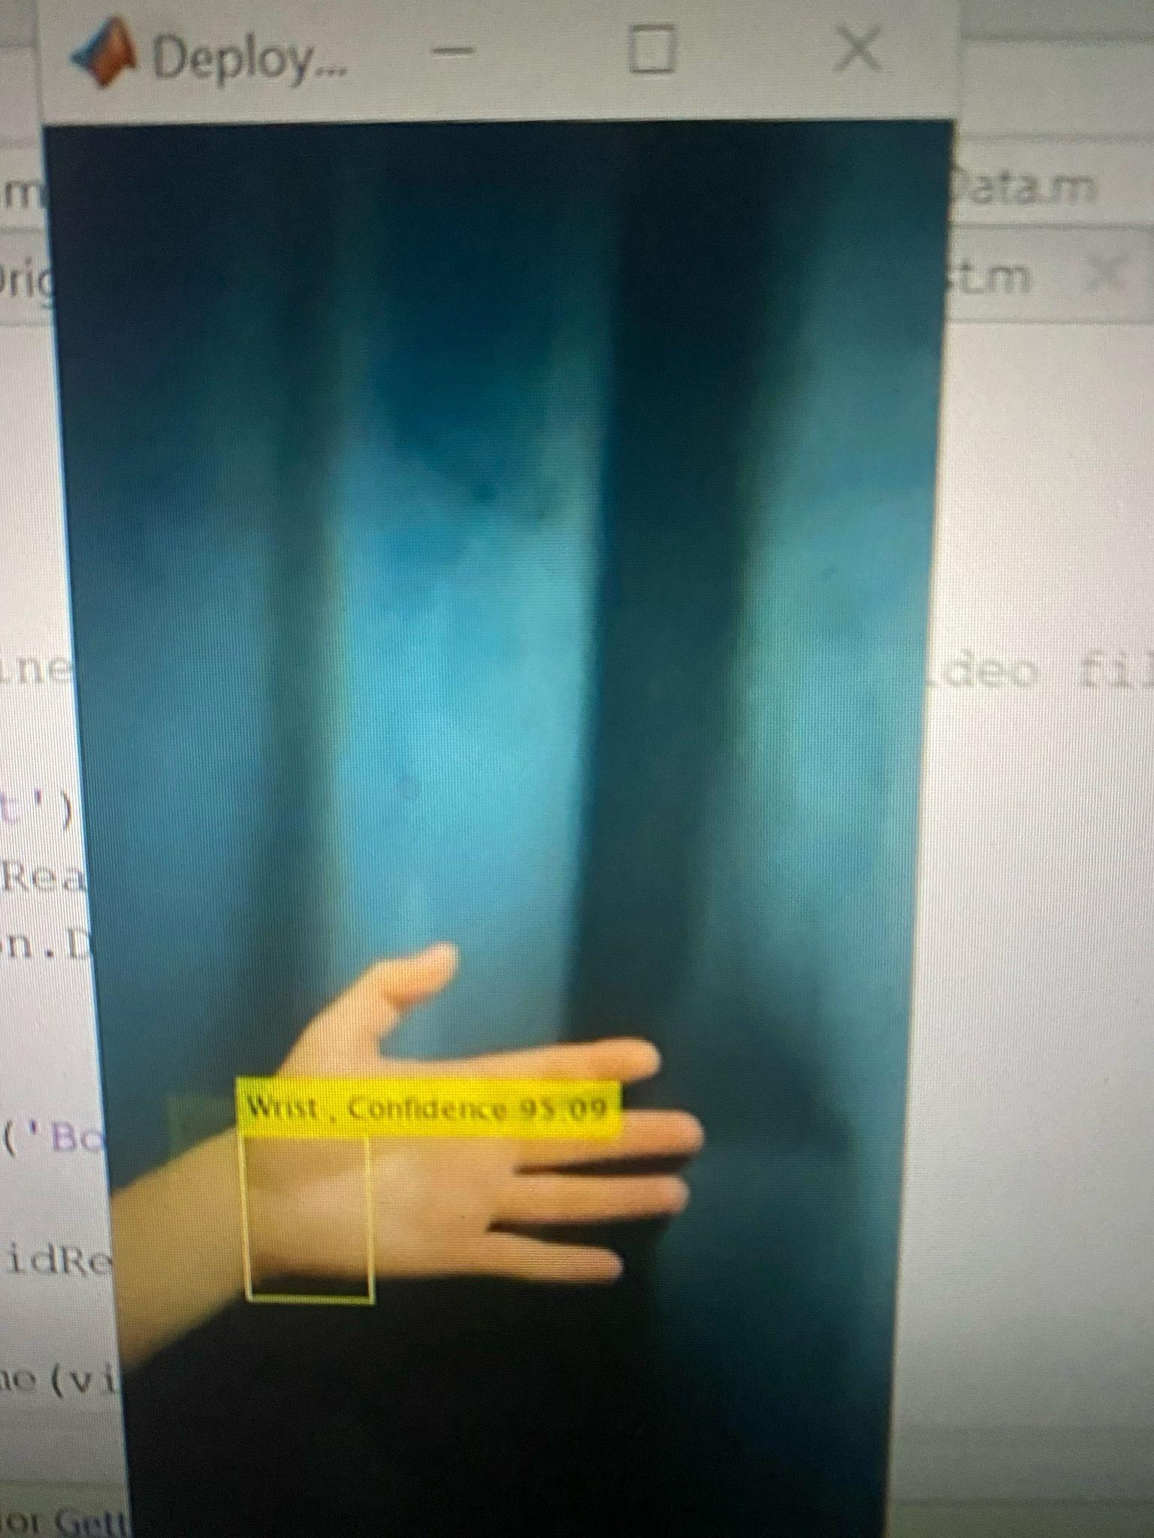

Figure 2: Result of image labeler app using machine learning to identify wrist

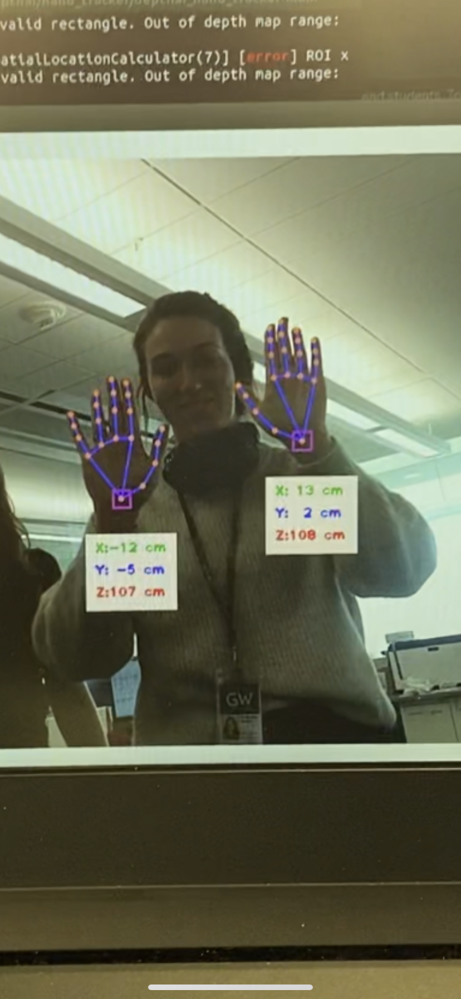

Figure 3: Example of live detection of hands, focusing on the wrists and returning wrist coordinates (can detect two hands in each frame, see here both the hands of one of my coworkers at GW)

**Robotic Arm Figures (Manish)**

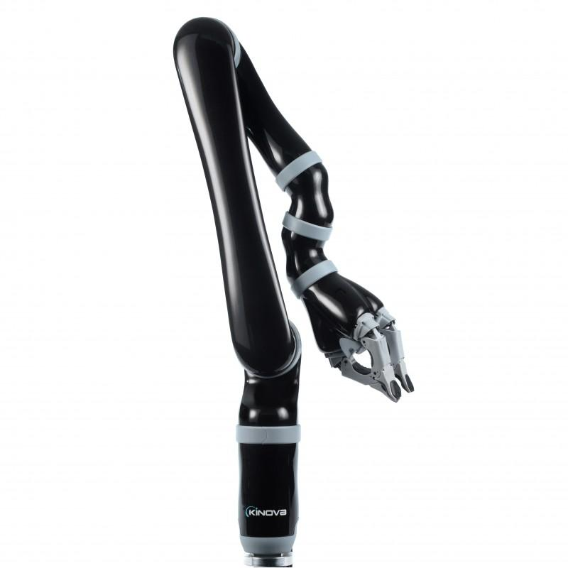

*Figure 4. Kinova Gen 2 Arm*

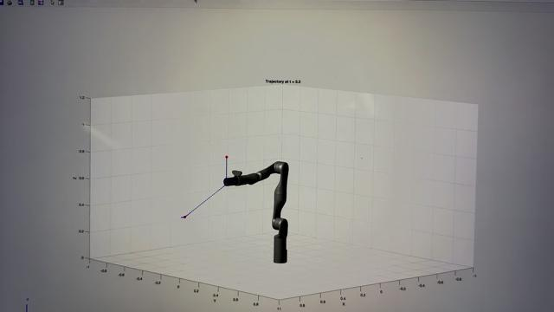

*Figure 5. Trajectory followed by robotic arm*

**Tactile Sensing Figures (Sagar)**

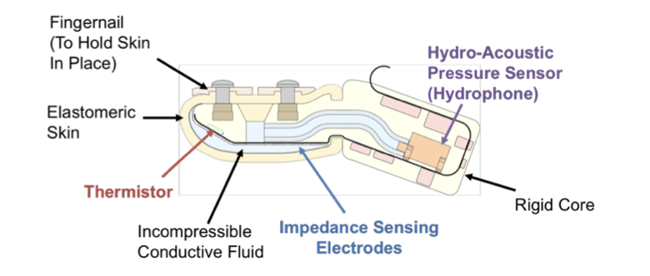

*Figure 6: Structure of Syntouch Biotac Tactile Sensor*

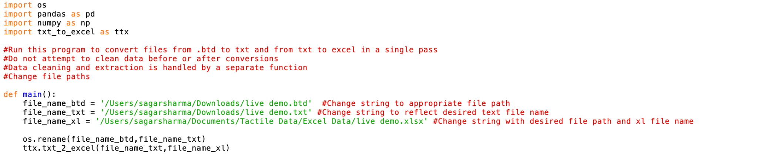

*Figure 7: File Conversion Function*

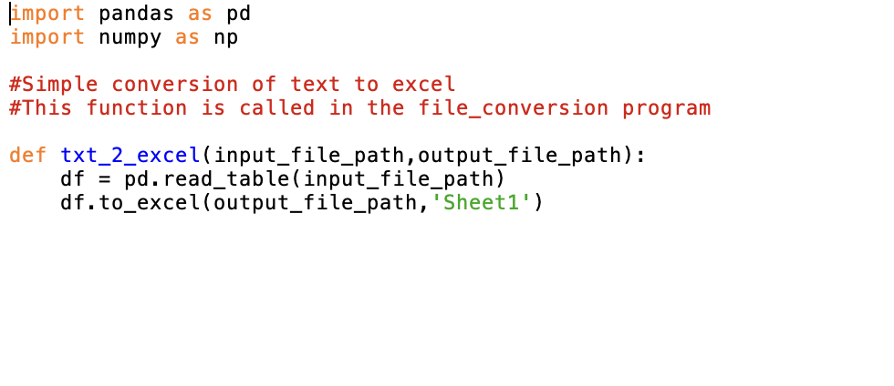

*Figure 8: ttx.txt_2_excel()*

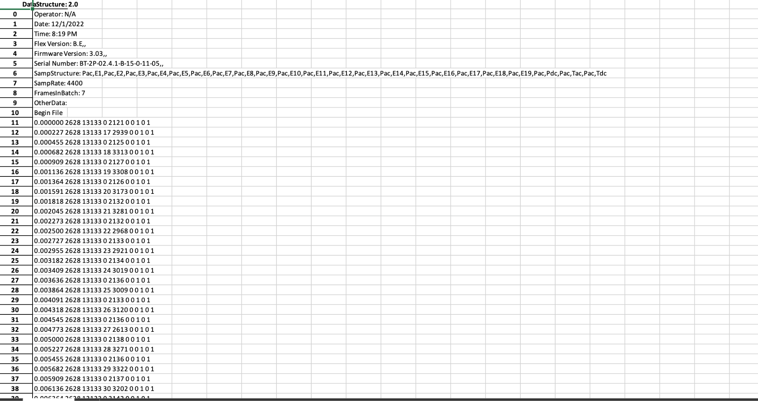

*Figure 9: Messy sensor data as outputted by GUI stored in excel file*

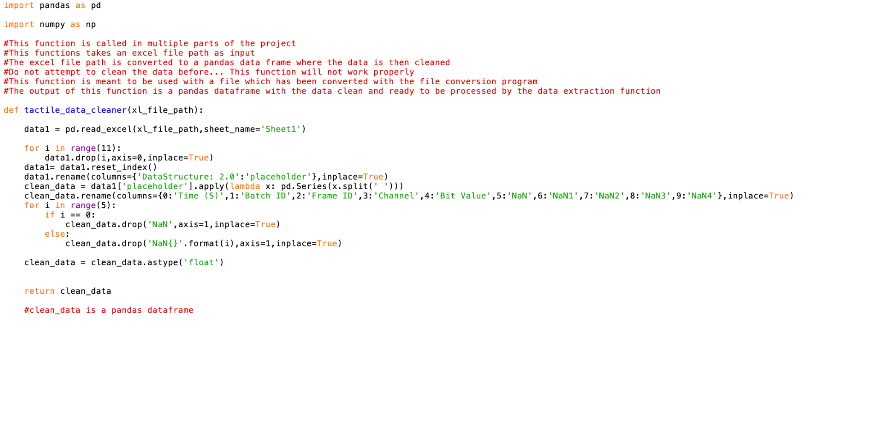

*Figure 10: Function to import data into Pandas data frame and to clean the data up*

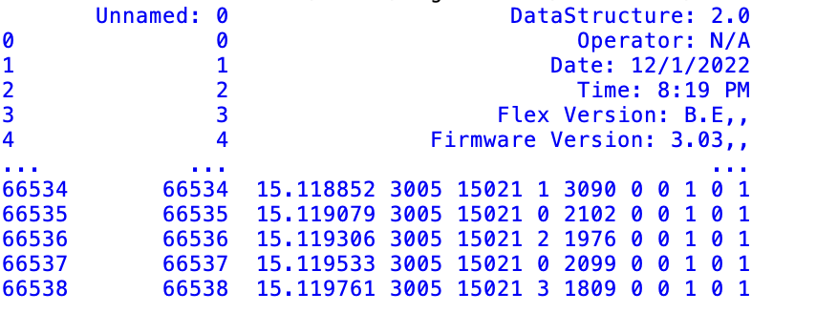

*Figure 11: Messy data in a Pandas data frame*

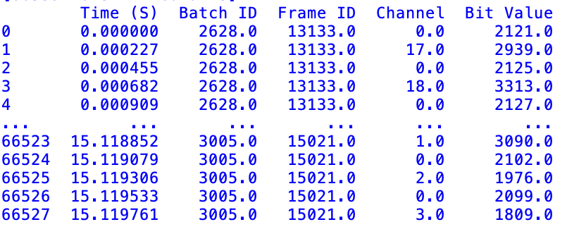

*Figure 12: Clean data in a Pandas data frame*

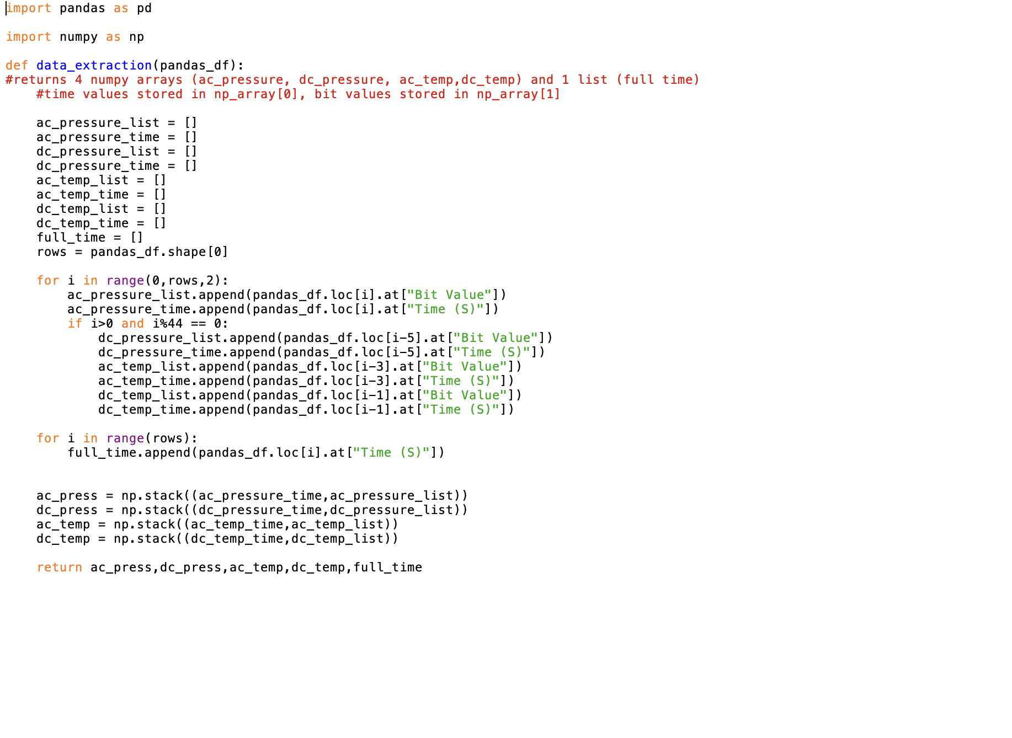

*Figure 13: Function used to extract the relevant signal values from the signal*

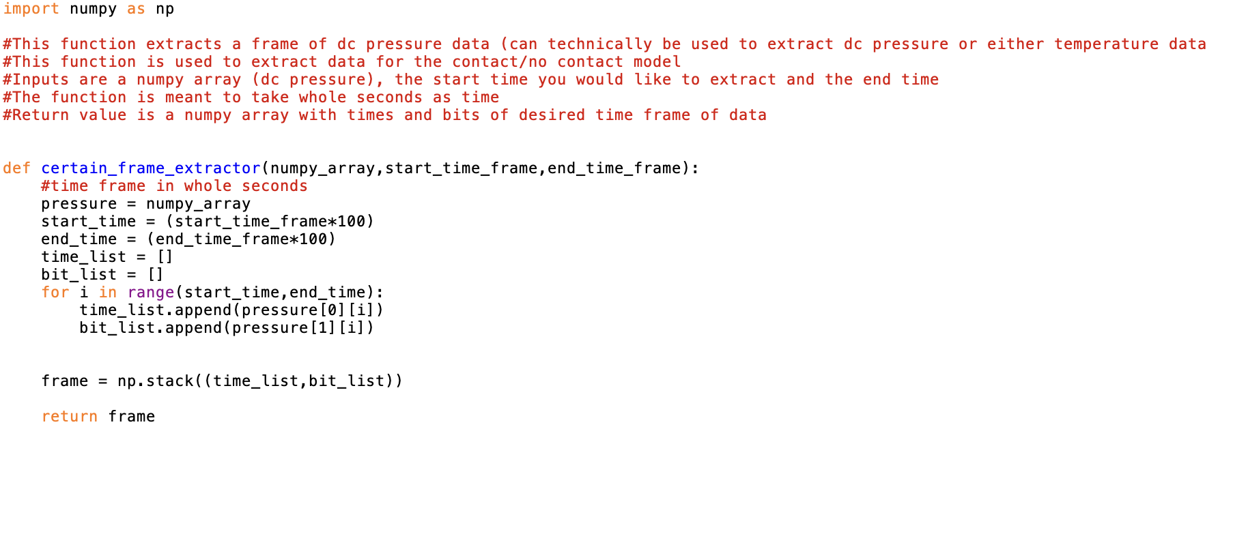

*Figure 14: Function to extract a certain frame a DC pressure data*

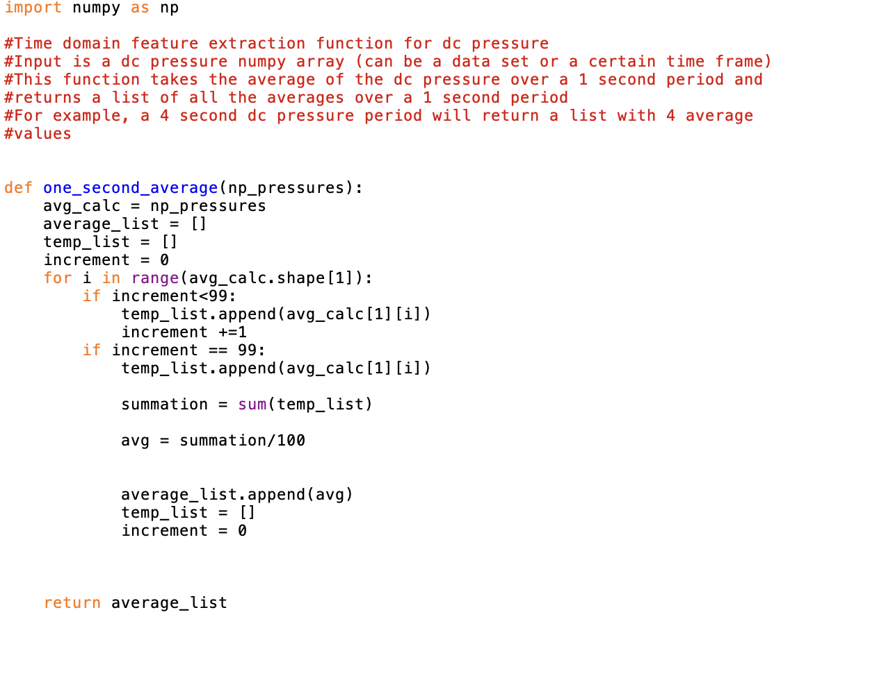

*Figure 15: Function to extract average DC pressure across 1 second of data for given input data*

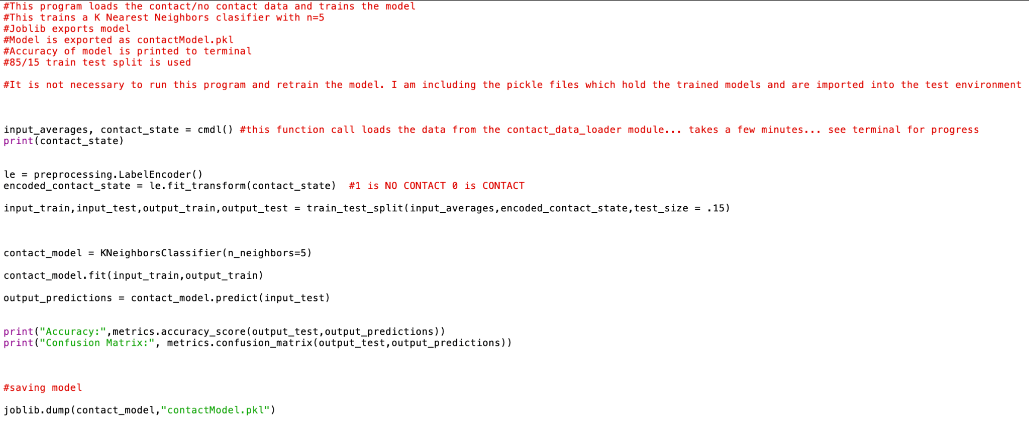

*Figure 16: Code to build contact/no contact model*

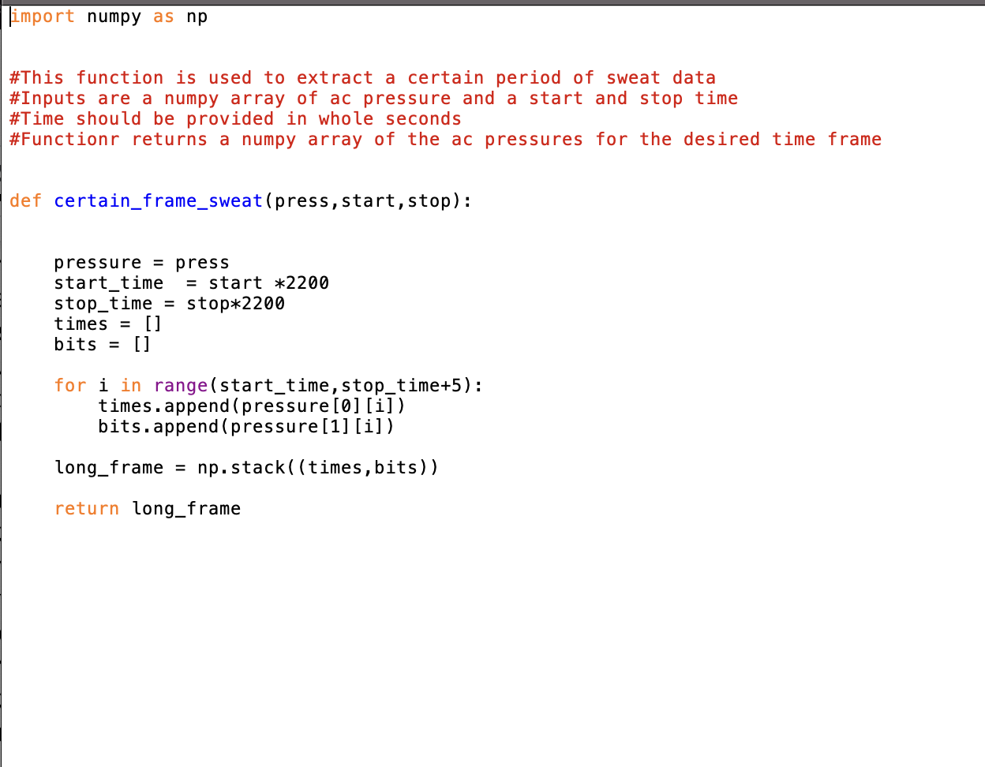

*Figure 17: Function to extract a certain time frame of AC pressure data*

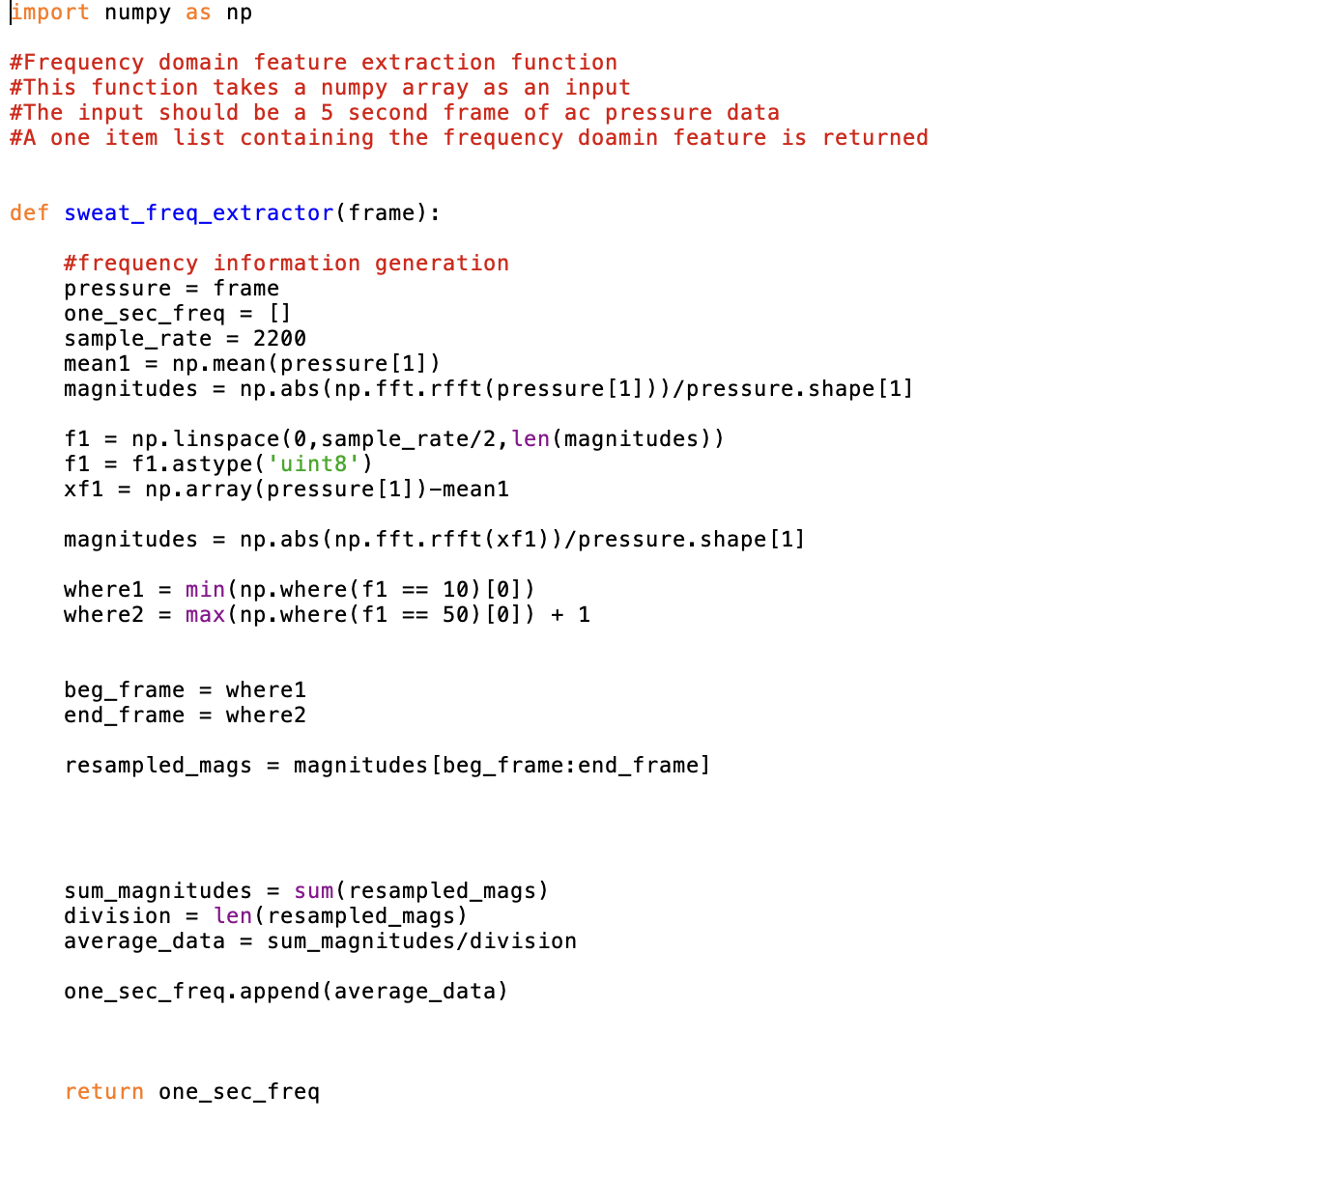

*Figure 18: Function to compute average of magnitude of frequencies from 10-40 Hz (AC Pressure)*

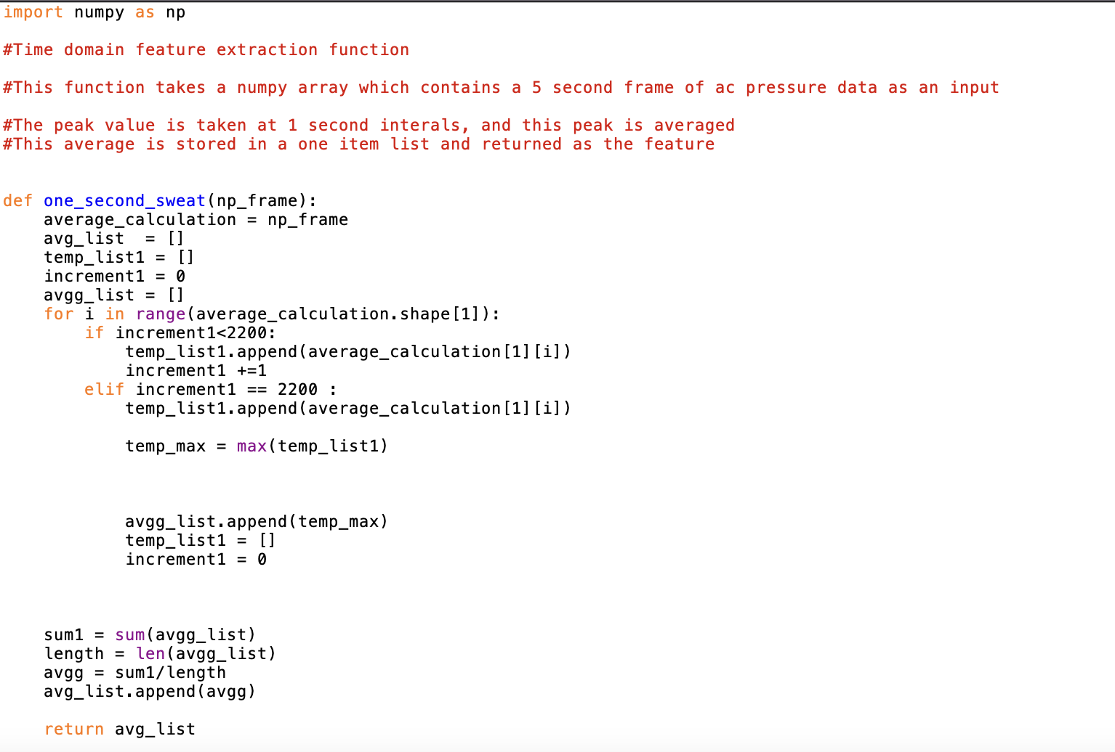

*Figure 19: Function to extract average AC pressure across a one second time frame*

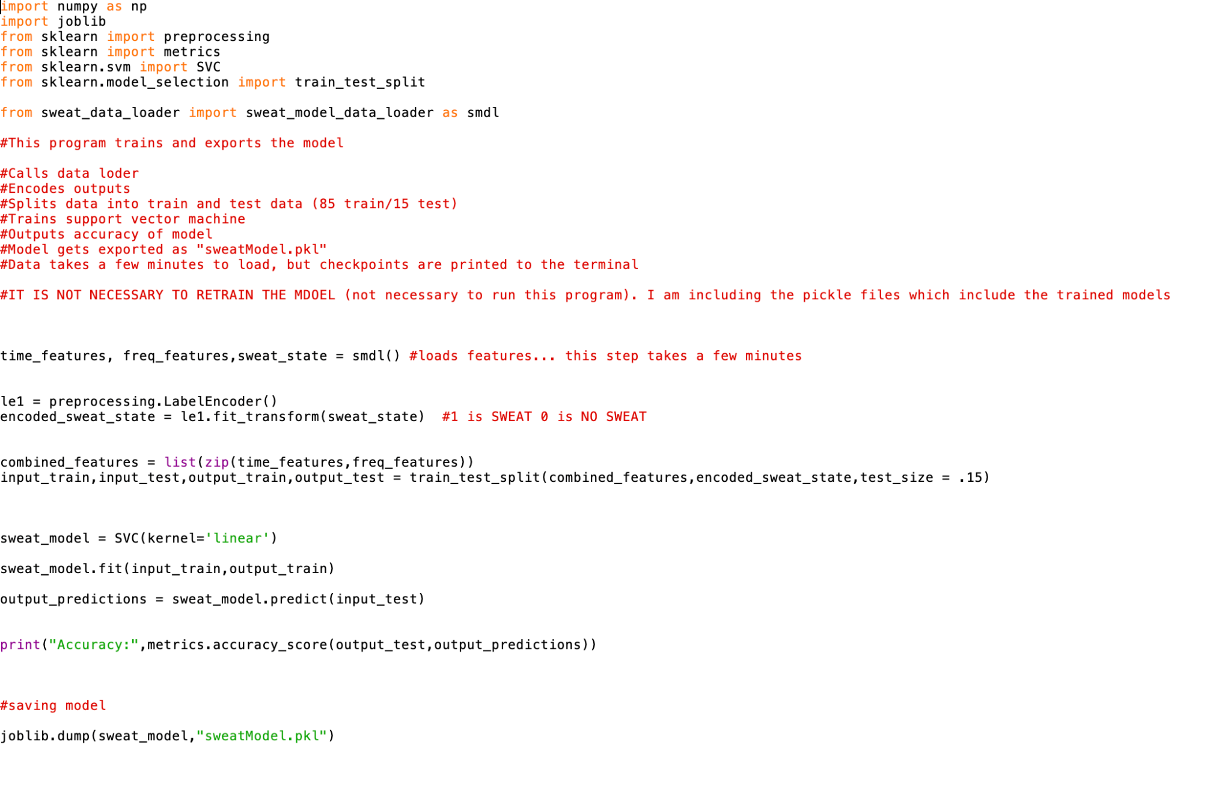

*Figure 20: Code to create the sweat/no sweat model*

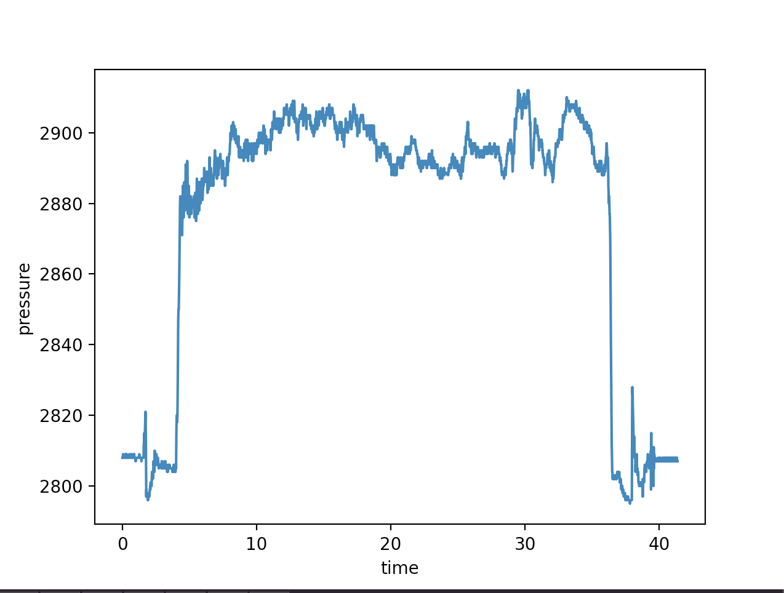

*Figure 21: DC Pressure VS. TIme plot, first few seconds and last few seconds represent no contact, middle represents contact*

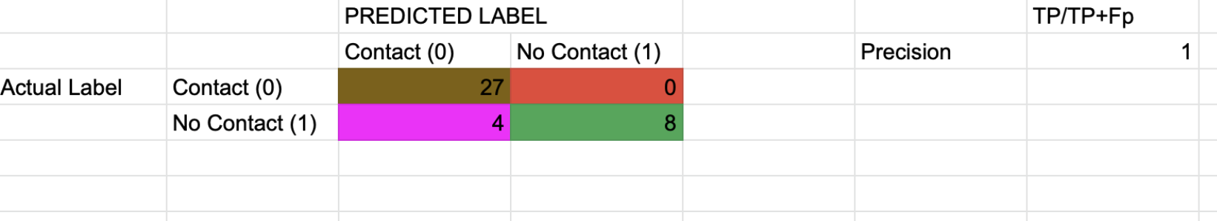

*Figure 22: Confusion matrix for contact/no contact model. Brown = True Negative, Pink = False Negative, Red = False Positive, Green = True Positive*

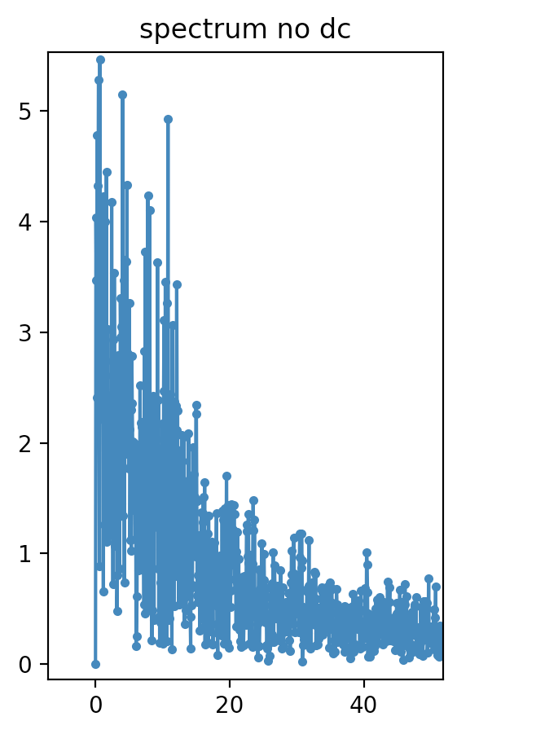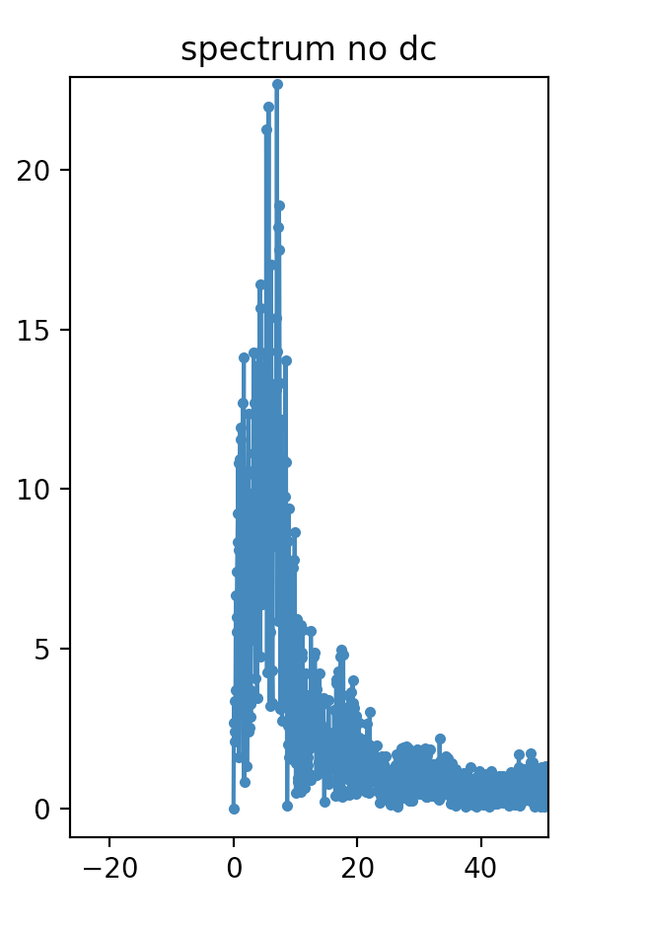

*Figure 23: AC Pressure frequency spectrum from 10-40 Hz. Wet skin on left, dry skin on right*

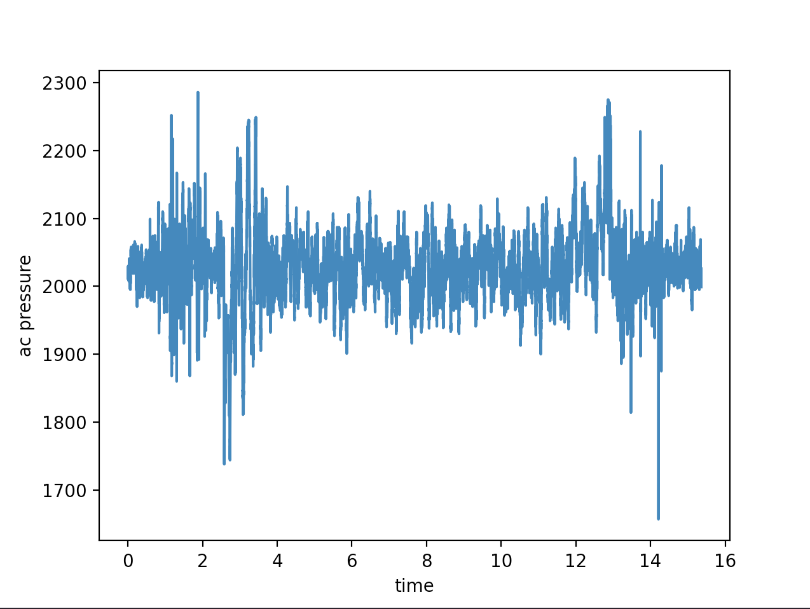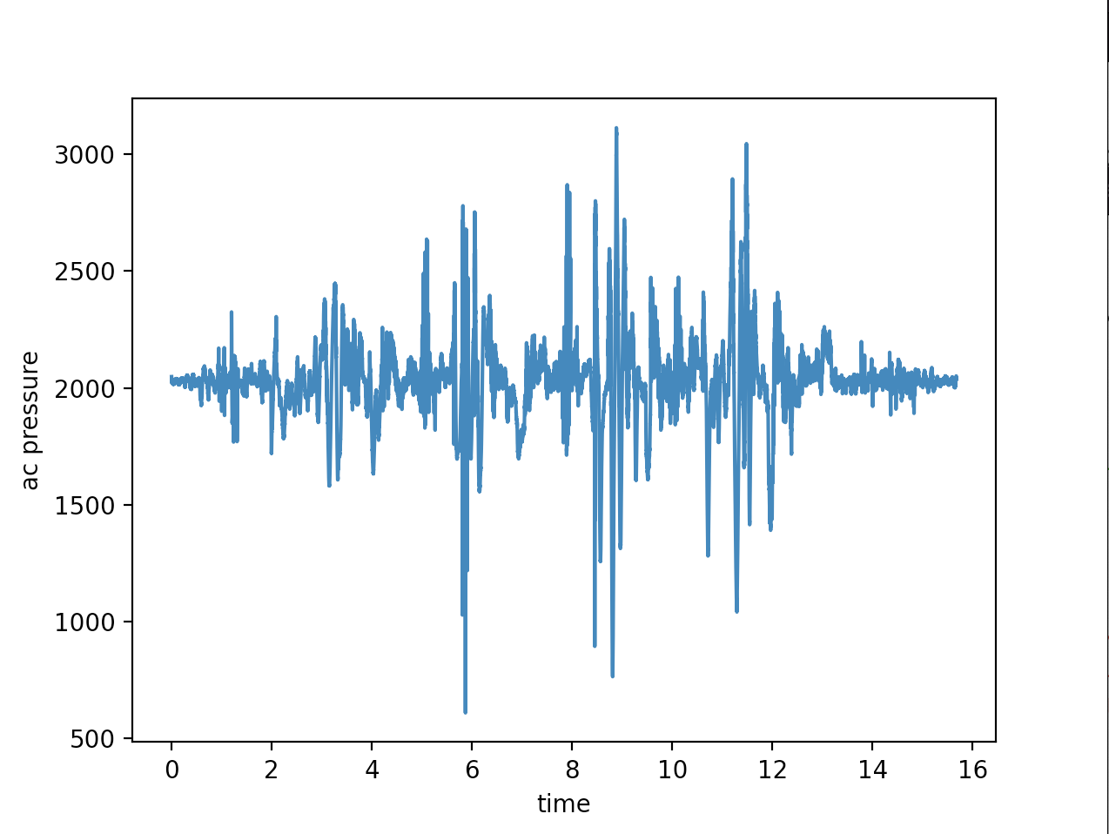

*Figure 24: AC Pressure in the time domain for wet skin on the left and dry skin on the right*

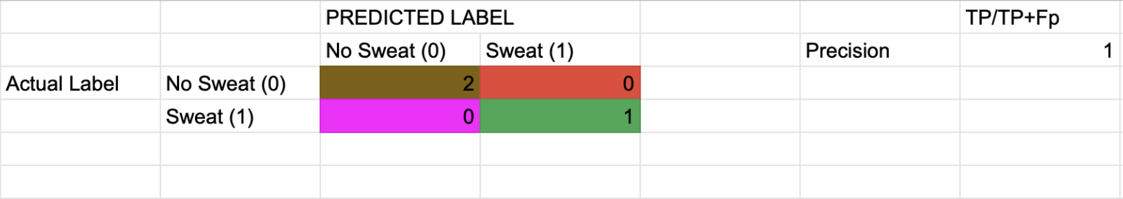

*Figure 25: Confusion matrix for sweat/no sweat model. Brown = True Negative, Pink = False Negative, Red = False Positive, Green = True Positive*

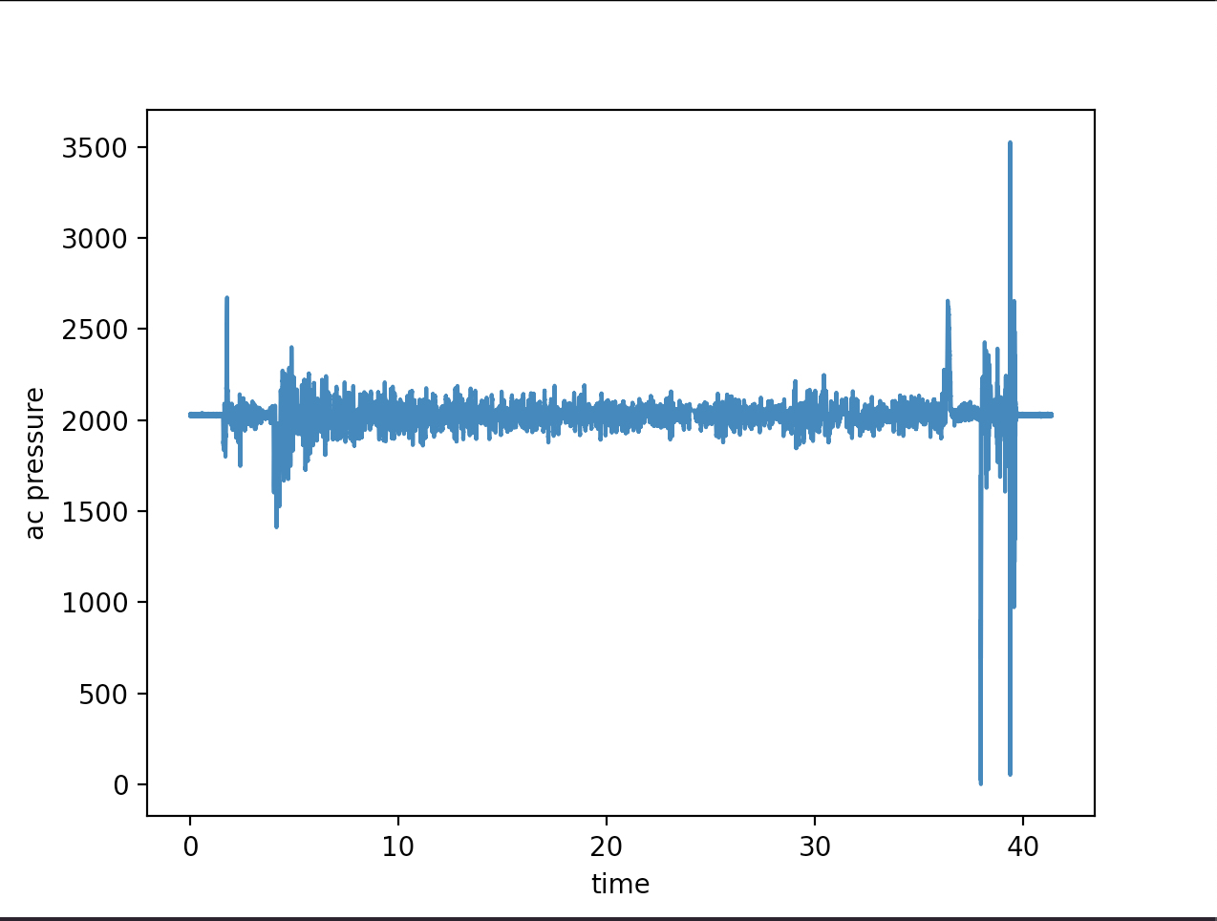

*Figure 26: AC Pressure vs time for a 100 BPM trial run*

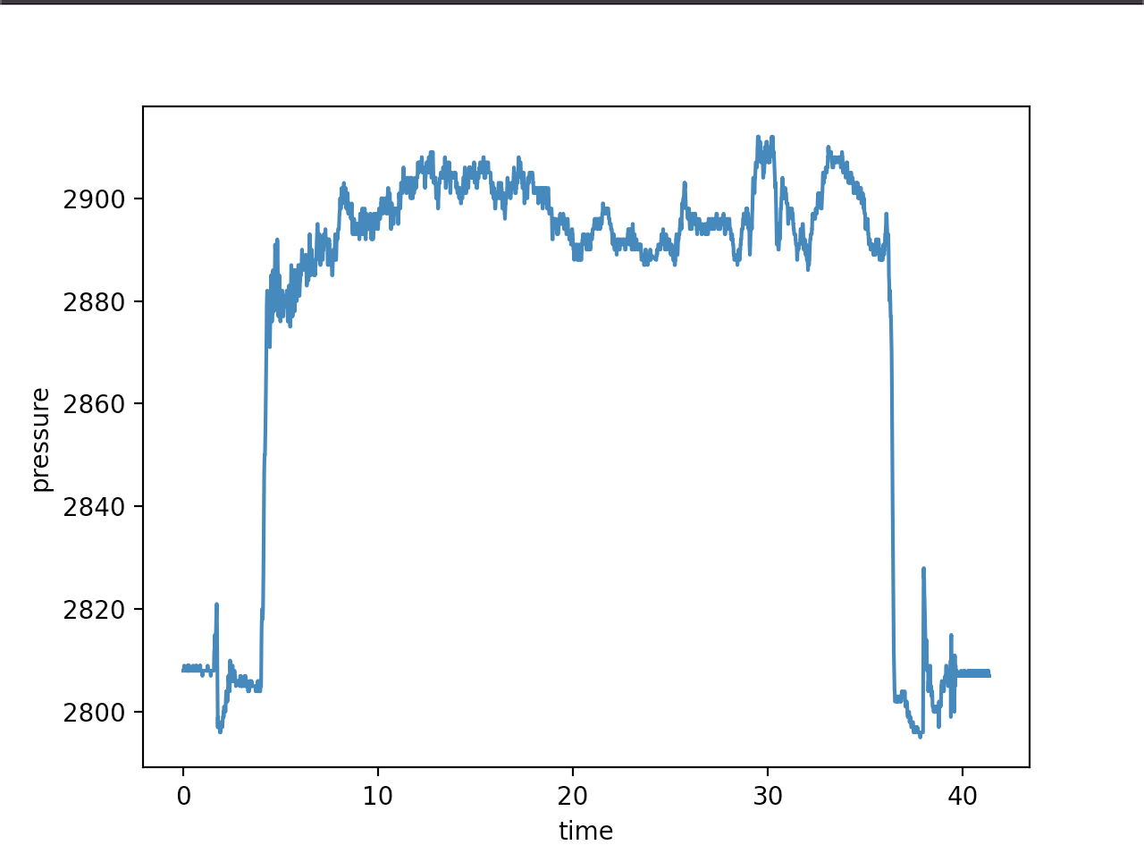

*Figure 27: DC Pressure vs time for a 100 BPM trial run*

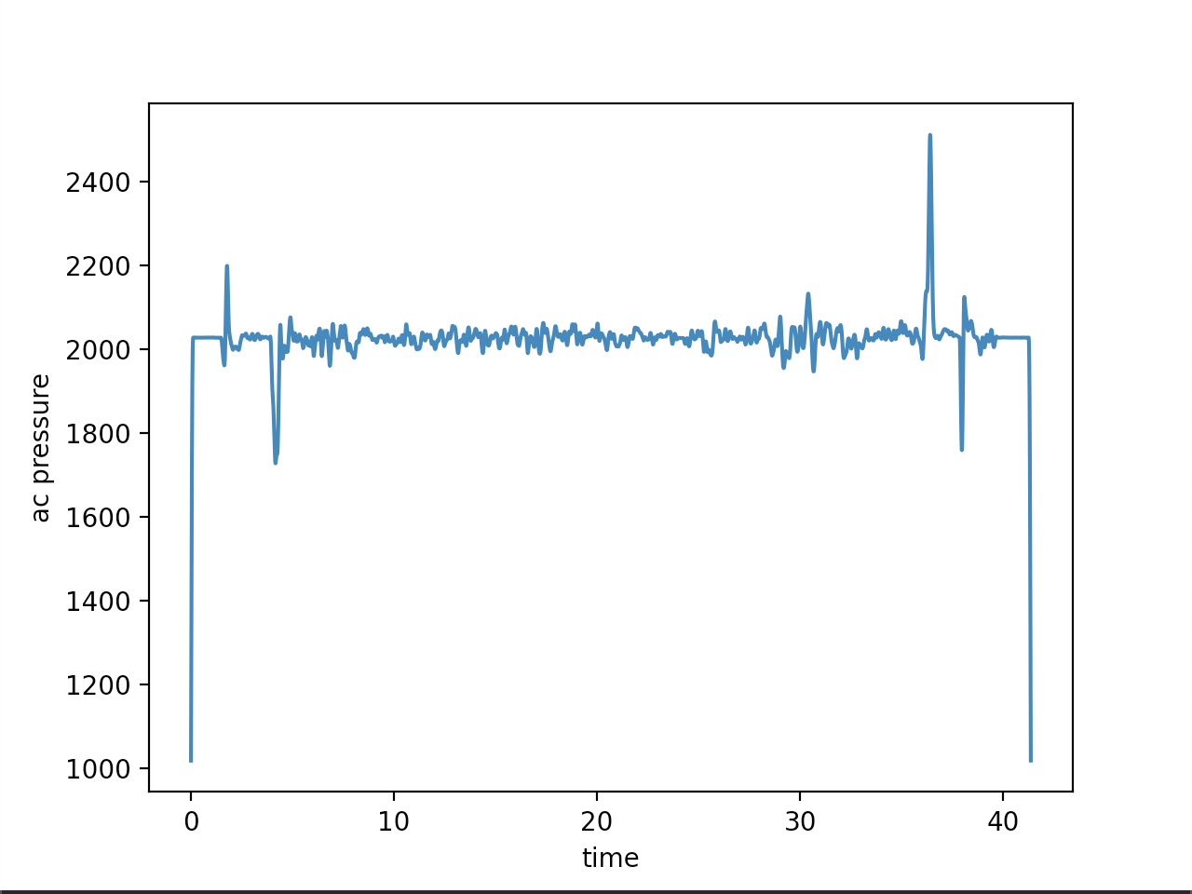

*Figure 28: AC Pressure signal vs time of a 100 BPM trial run after being convolved with a Hann Kernel of size 501*

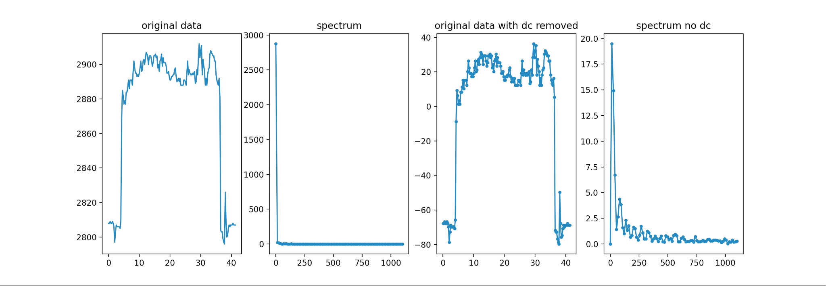

*Figure 29: DC Pressure signal after being resampled to 1 sample every quarter second. Representations from left to right: resampled time date, resampled frequency spectrum, resampled time data with dc component removed, resampled frequency spectrum with DC component removed*